JavaScript Algorithms and Data Structures Masterclass

# Section 18: Intro to Data Structures

## What are Data Structures?

* Collections of values, relationships between values, and functions that can be applied to the data

### ES2015 Class Syntax

* 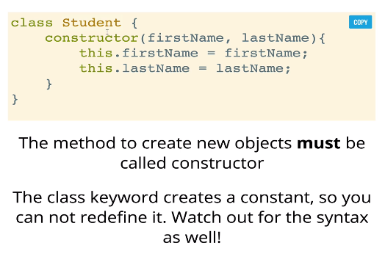
* 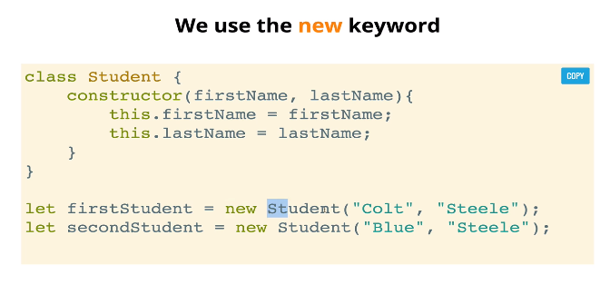
* **Class Methods**:
  + They are ‘utility’ functions and are not relevant to an individual instance of a class
    - **ex**. Student.enroll();
      * 
 